Chapter 13, Problem 12.

Determine the equivalent L_{eq} in the circuit of Fig. 13.81.
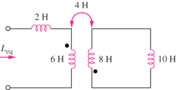
20H
16H
12H
8H
4H

Figure 13.81
For Prob. 13.12.

